Lab 9 - Build collaborative workflows using Microsoft Teams Chat and AI-based suggestions in Dynamics 365 Contact Center
Introduction
This lab guide focuses on configuring Microsoft Teams Chat collaboration features and suggested contact capabilities in Dynamics 365 Contact Center. In this lab, you will enable Microsoft Teams Chat integration, configure chat connections for record types, manage chat disconnection and join settings, and enable both AI-based and rules-based suggested contacts. By completing this lab, learners gain practical experience in building collaborative workflows that connect Dynamics 365 records with Microsoft Teams conversations and intelligent contact suggestions.

Exercise 1 - Configure Microsoft Teams Chat integration
In this exercise, you will enable Microsoft Teams Chat in the Copilot Service admin center and configure how chats connect to Dynamics 365 records. You will also add additional record types, manage chat disconnection behavior, and configure the join chat setting. This exercise establishes the collaboration foundation required for Microsoft Teams-based communication in the Contact Center environment.

Task 1 - Enable Microsoft Teams Chat and integration
- Log in to the Contact Center environment by using Admin Tenant credentials. Admin tenant is assigned the required Global administrative role to perform this exercise.
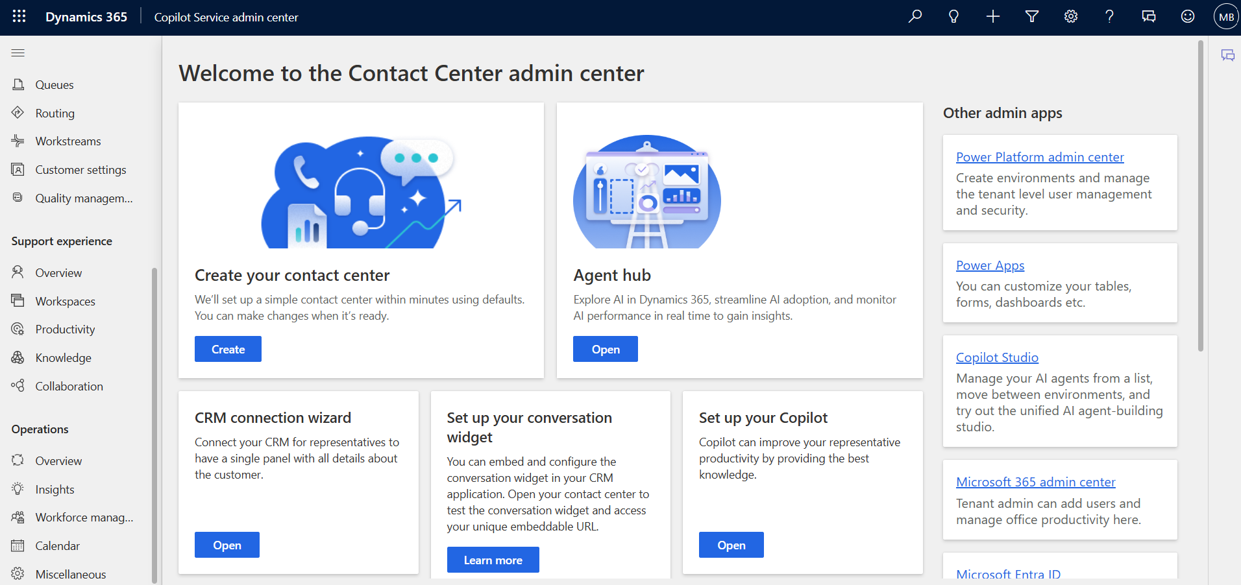
- In the Copilot Service admin center, go to Support experience and select Collaboration.
- In Embedded chat using Teams, select Manage.
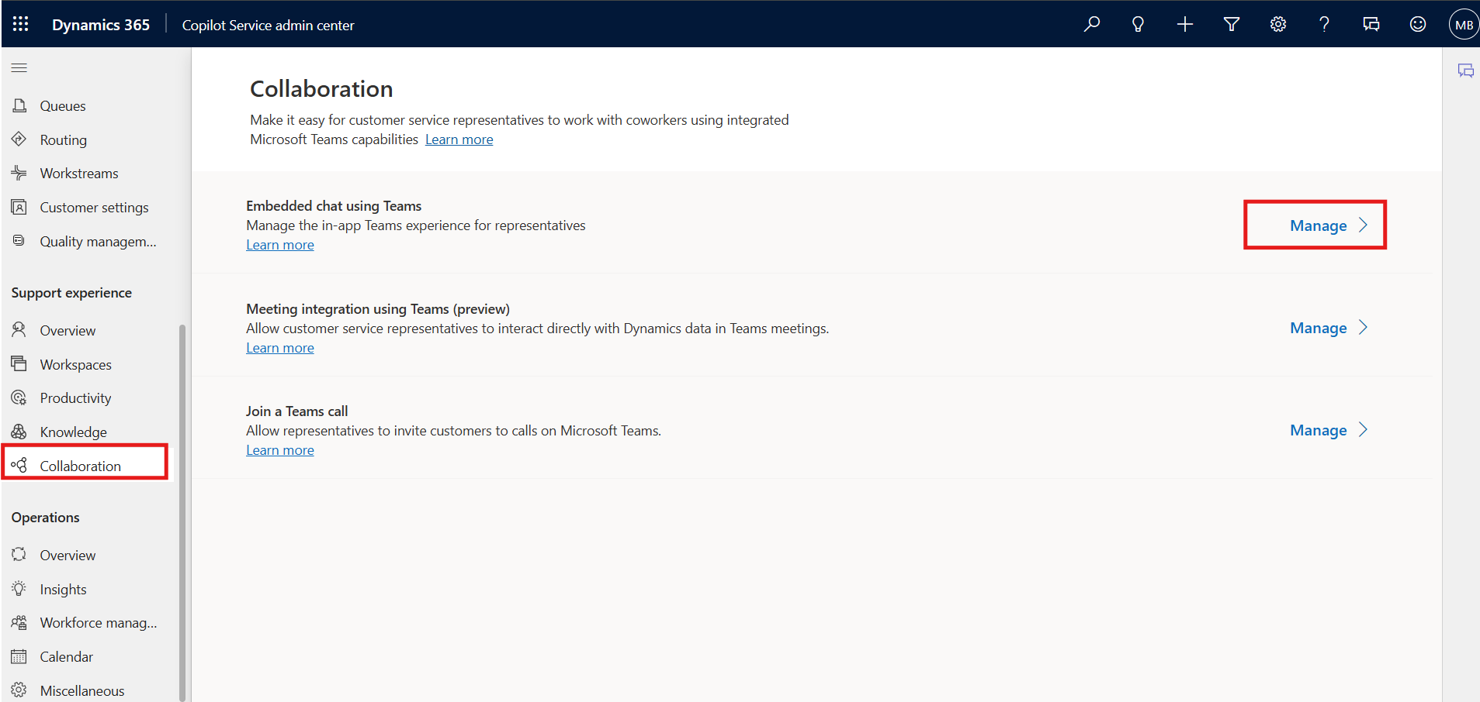
- On the Microsoft Teams collaboration and chat page, turn on the toggle for Turn on Microsoft Teams chats inside Dynamics 365 and select Turn on for all Dynamics 365 apps.
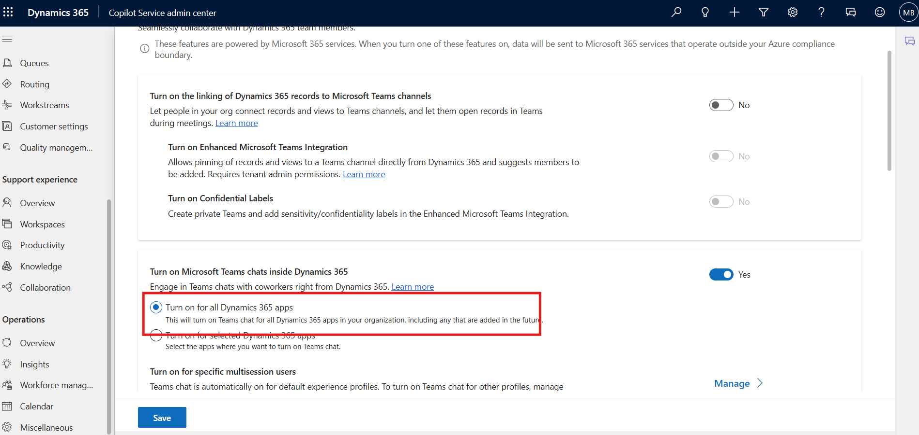
- Next, set the toggle for Turn on the linking of Dynamics 365 records to Microsoft Teams channels to Yes. This setting requires tenant admin permission.
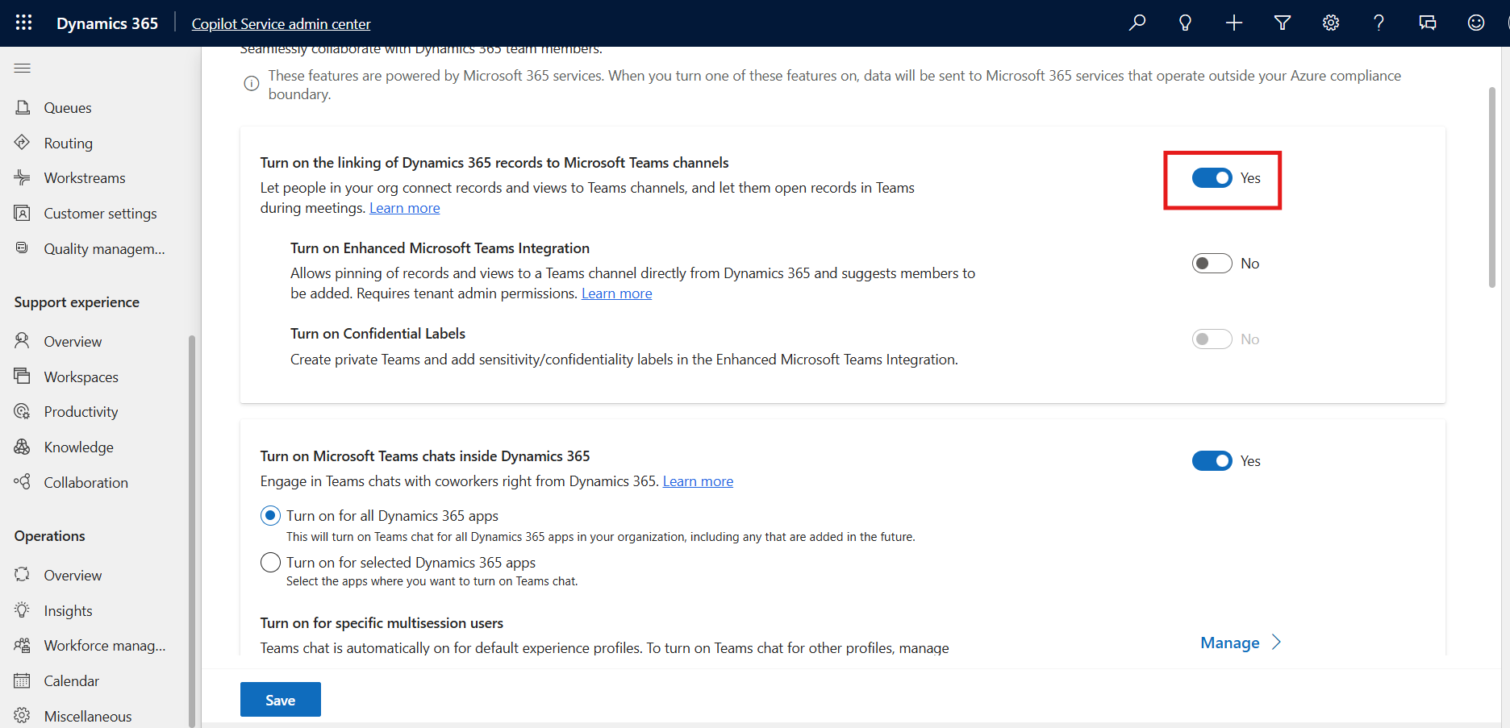
- Next, set the toggle for Turn on Enhanced Microsoft Teams Integration to Yes. This setting requires tenant admin permission.
- Sign in (if prompted) and then accept the consent.
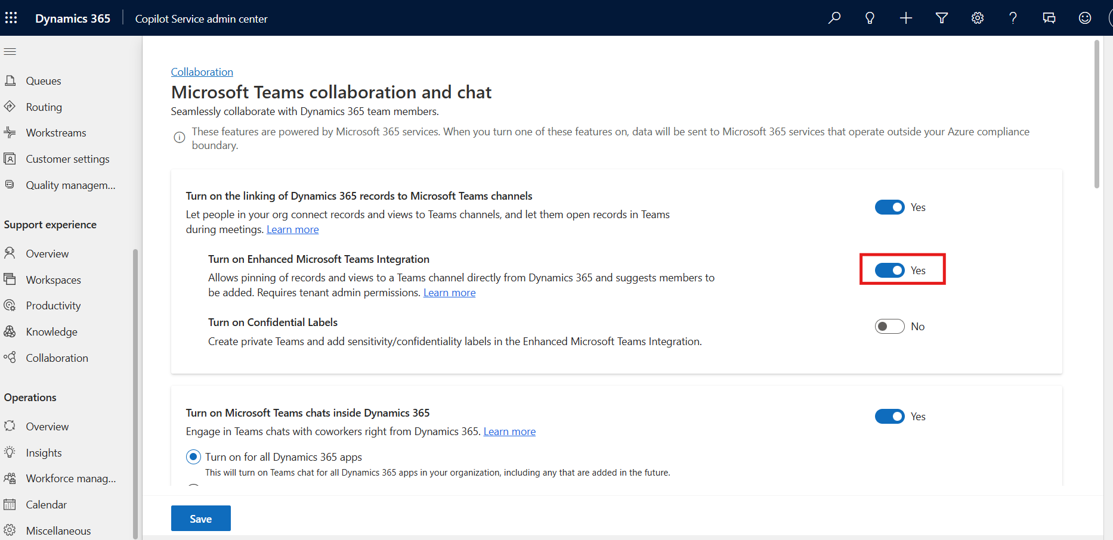
- Next, set the toggle for Turn on Confidential Labels to Yes. This setting requires tenant admin permission.
- Sign in (if prompted) and then accept the consent.
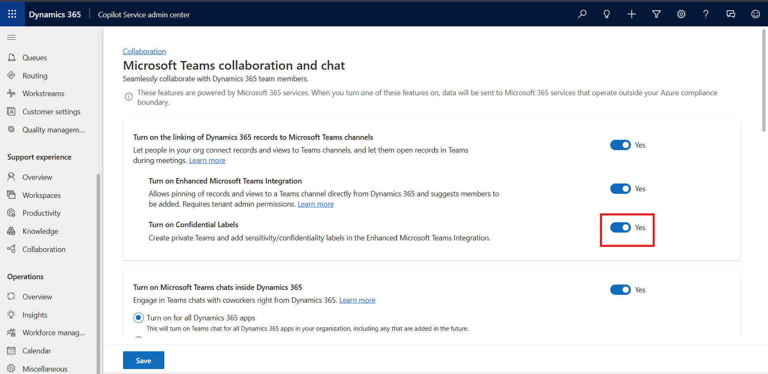
- From the bottom-left corner, click Save.
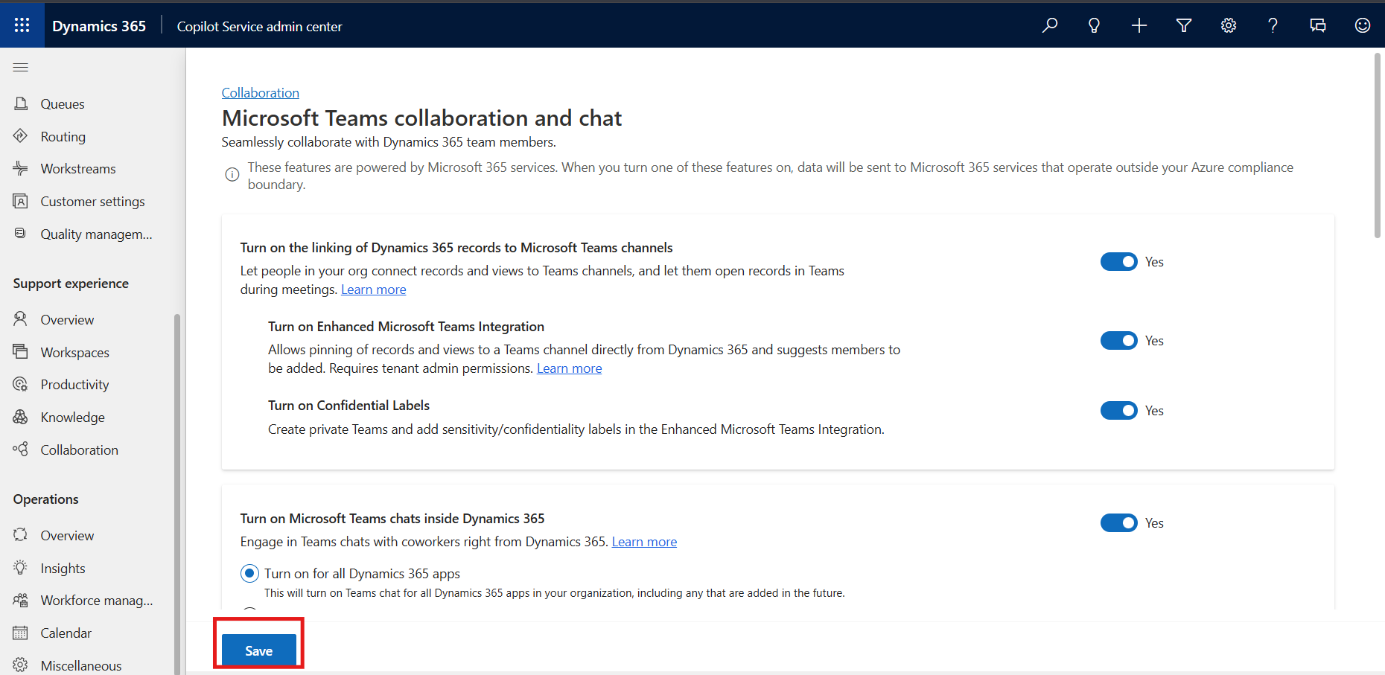

Task 2 - Configure chat connections for record types
- In the Copilot Service admin center or Contact Center admin center, go to Support experience, and select Collaboration.
- In Embedded chat using Teams, select Manage.
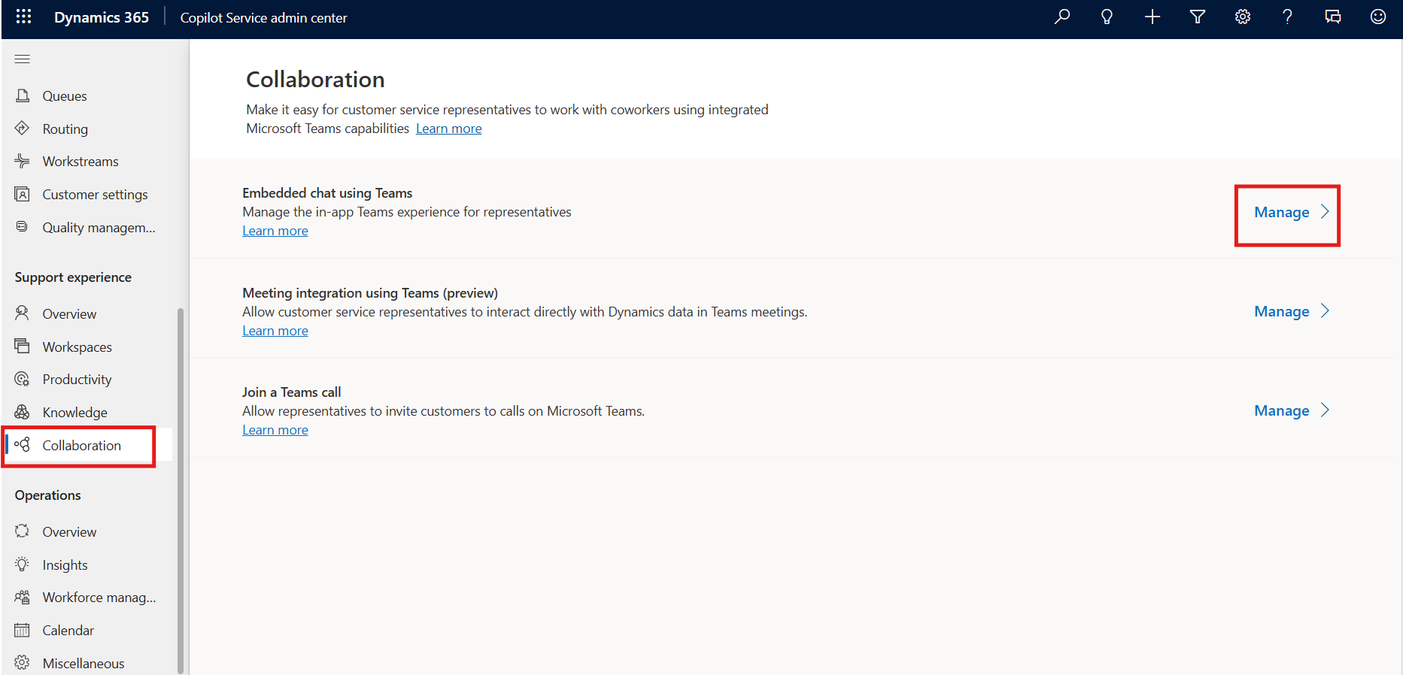
- Under Connect chats to Dynamics 365 records, select the record type you want to configure. For example, select Case record.
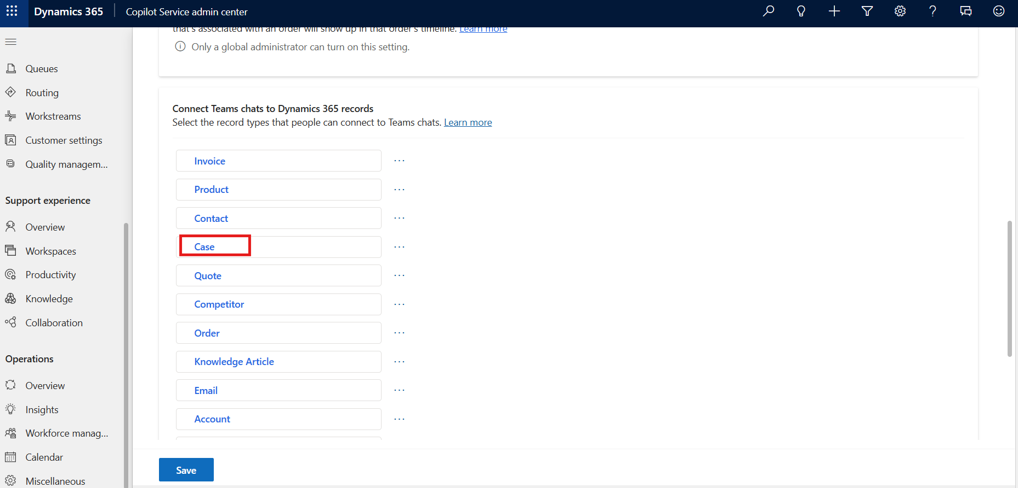
- Click on the Message view field and select All case, then click Save.
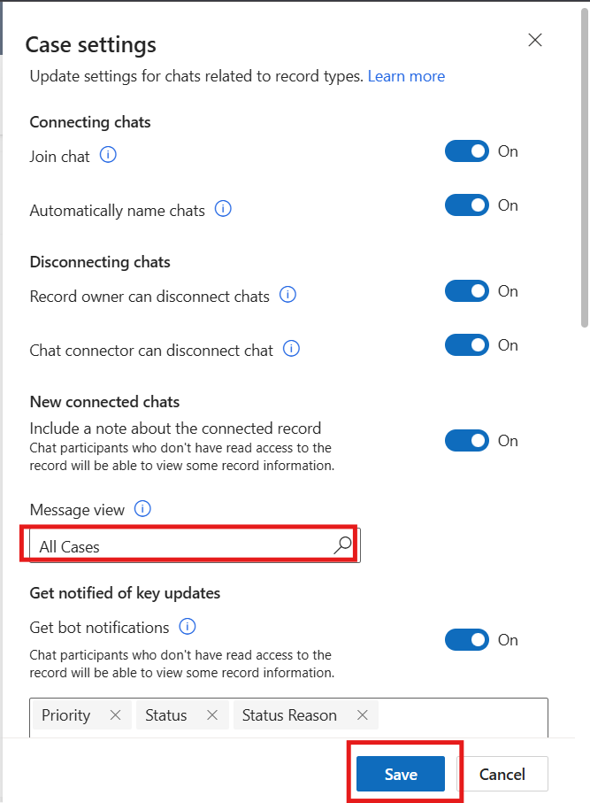

Task 3 - Add additional record types for chat connections
- Under Connect chats to Dynamics 365 records, select Add record types.
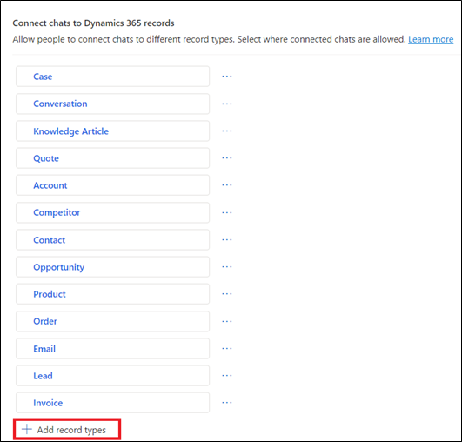
- On the Allow chats to be connected to this record type page, in Choose record type, select the name of the record type you want to use. For example, select Available Times.
- Select Save.
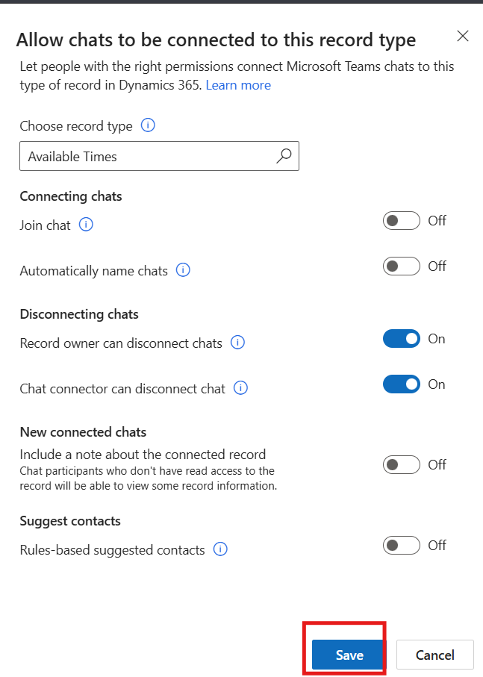

Task 4 - Configure chat disconnection settings
- In the Copilot Service admin center or Contact Center admin center, go to Support experience, and select Collaboration.
- In Embedded chat using Teams, select Manage.
- Under Connect chats with Dynamics 365 records, select the record type you want to configure, for example, Case.
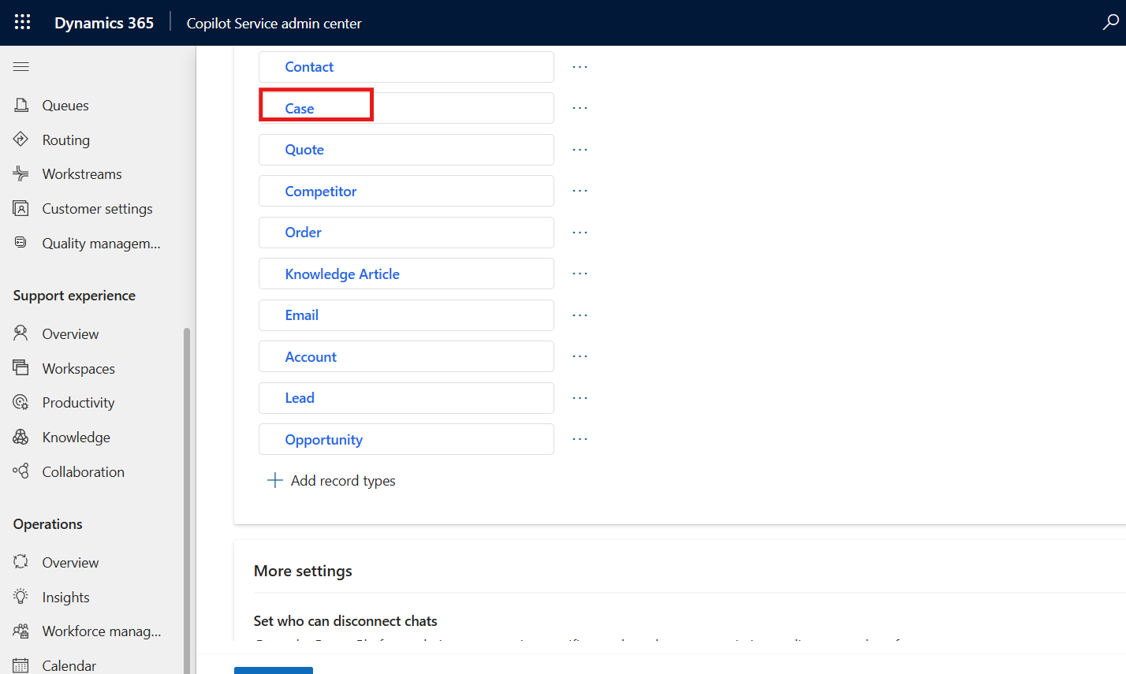
- On the Case settings pane, in Disconnecting chats, toggle off Chat connector can disconnect chats and then click Save.
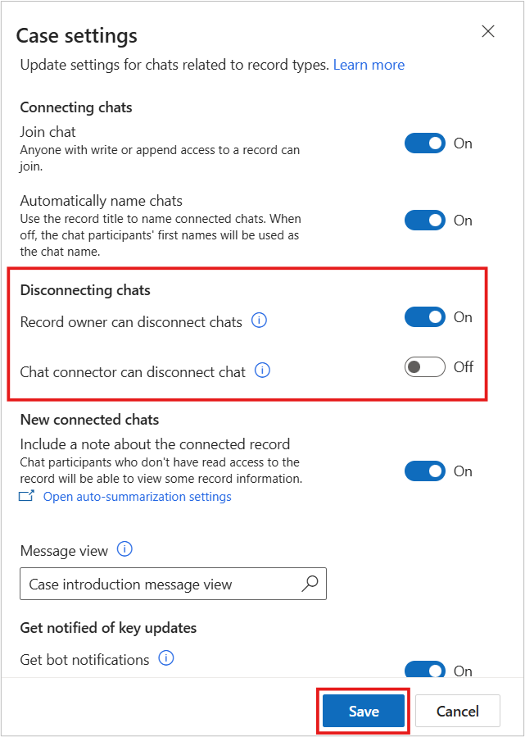

Task 5 - Toggle join chat setting
- In the Copilot Service admin center or Contact Center admin center, go to Support experience, and select Collaboration.
- In Embedded chat using Teams, select Manage.
- On the Microsoft Teams collaboration and chat page, in Connect chats to Dynamics 365 records, select the specific record type, for example, Case.

- In the settings pane, toggle Join chat on or off.
- Click Save.
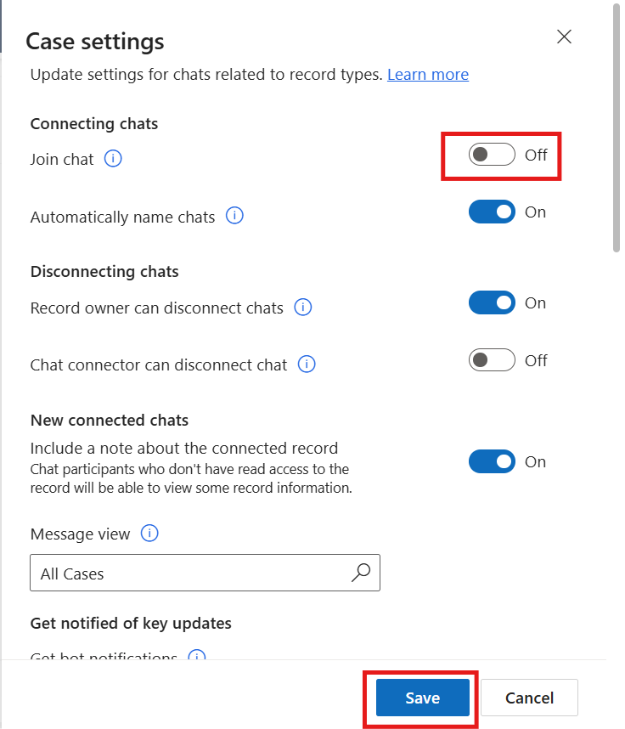

Exercise 2 - Enable AI-based suggested contacts
In this exercise, you will enable AI-based suggested contacts for supported record types in the collaboration settings. This feature helps agents identify relevant contacts during support interactions by using processed organizational data.

Task 1 - Enable AI-based suggested contacts
- In the site map of Copilot Service admin center, go to Support experience > Collaboration.
- In Embedded chat using Teams, select Manage.
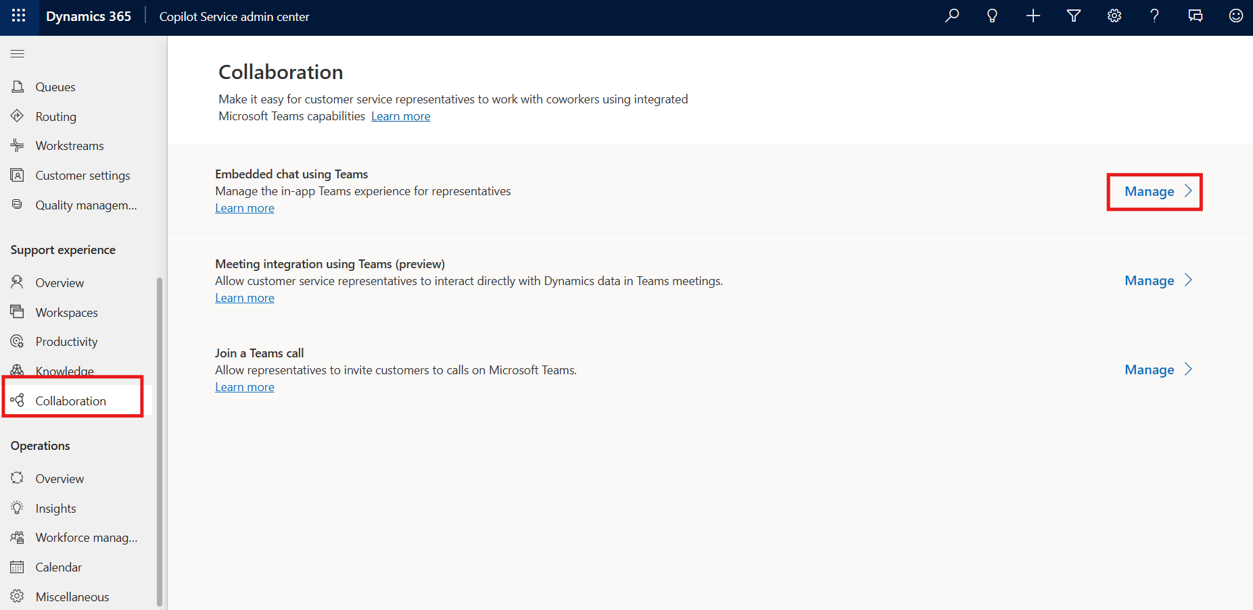
- To get suggested contacts for active cases or supported conversations, perform the following:
  - In Connect chat to Dynamics 365 records, select Case. The Conversation settings pane appears on the right.
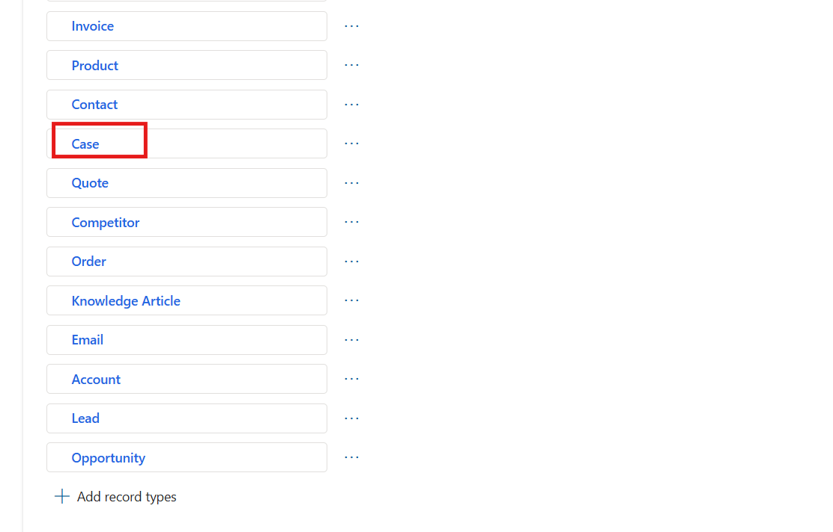
  - In Suggest contacts, turn on the toggle for AI-based suggested contacts and then select Save.
  - Select Save on the Microsoft Teams collaboration and chat page to reflect the changes.
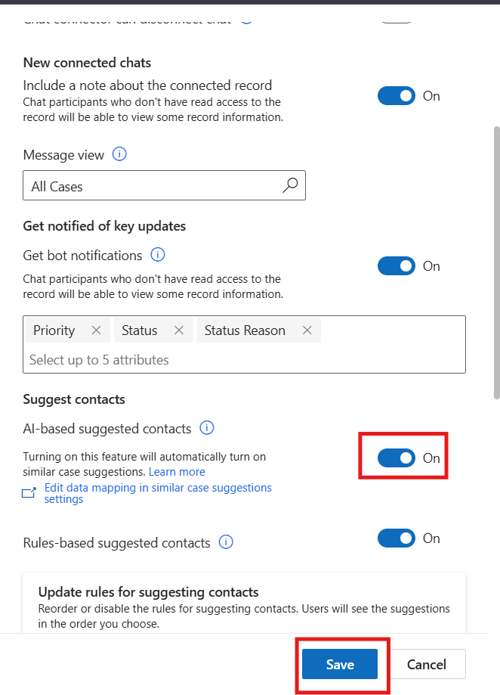
- Note that it takes 24 hours for the data to be preprocessed for first-time use.

Exercise 3 - Configure rules-based suggested contacts
In this exercise, you will enable rules-based suggested contacts for a record type and manage the rules used to generate those suggestions. You will also create a new relational rule to control how suggested contacts are surfaced to users.

Task 1 - Enable rules-based suggested contacts
- In the site map of the Copilot Service admin center, under Support experience, select Collaboration.
- In Embedded chat using Teams, select Manage.
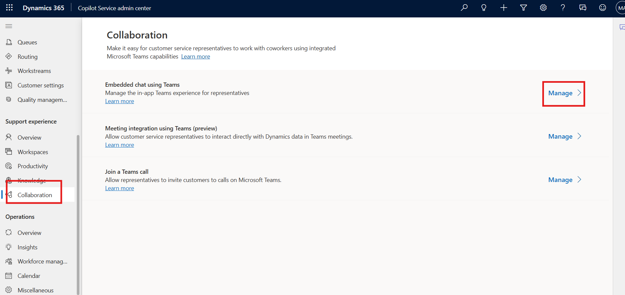
- To get suggested contacts for any record type, perform the following:
  - In Connect chat to Dynamics 365 records, select the record type Case for which you want to enable rules-based suggested contacts. The related settings pane appears on the right.
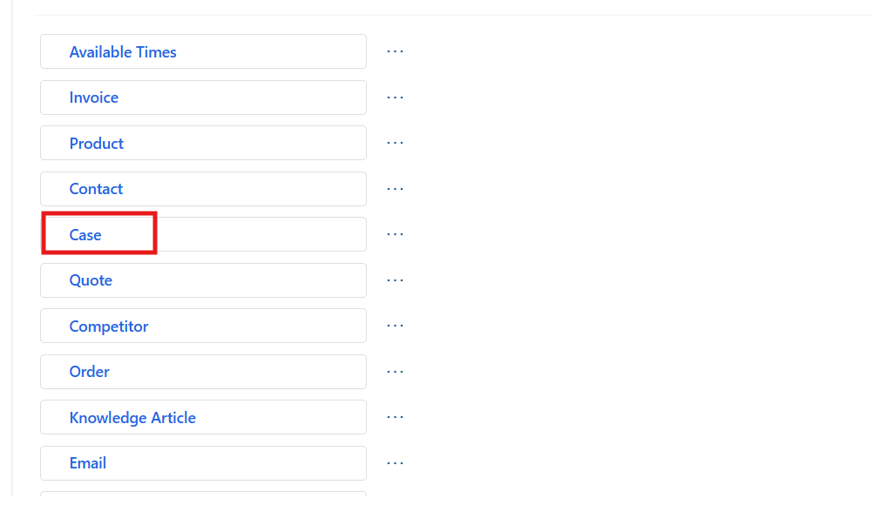
  - In Suggest contacts, ensure the toggle for Rules-based suggested contacts is turned on. If it is already enabled and the Save option is inactive.
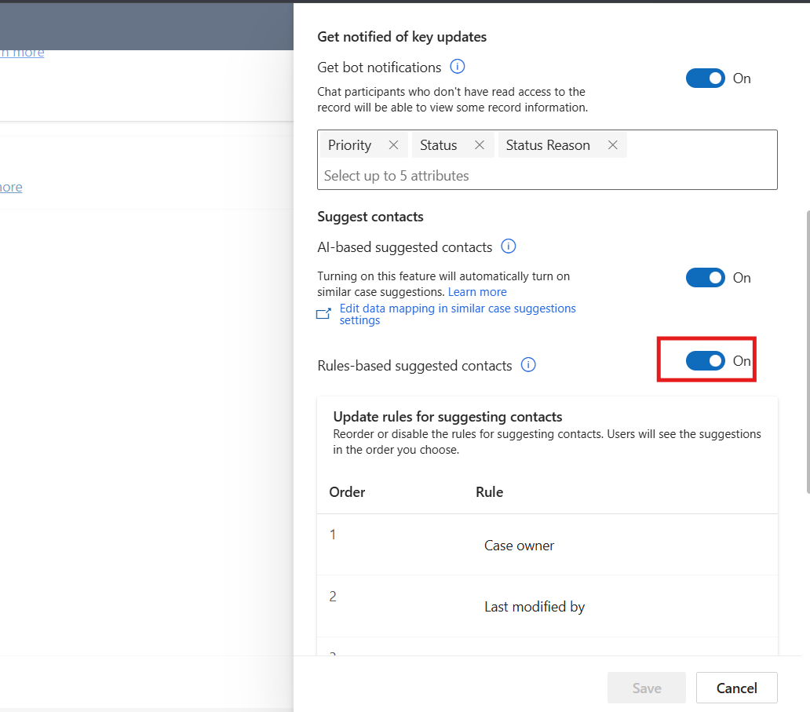
- In the Update rules for suggesting contacts section on the Case record, reorder or disable the rules for suggesting contacts. Users see the suggestions in the order you choose.
  - To reorder the rules, hover over a rule, and then select the up or down arrow to move the rules.
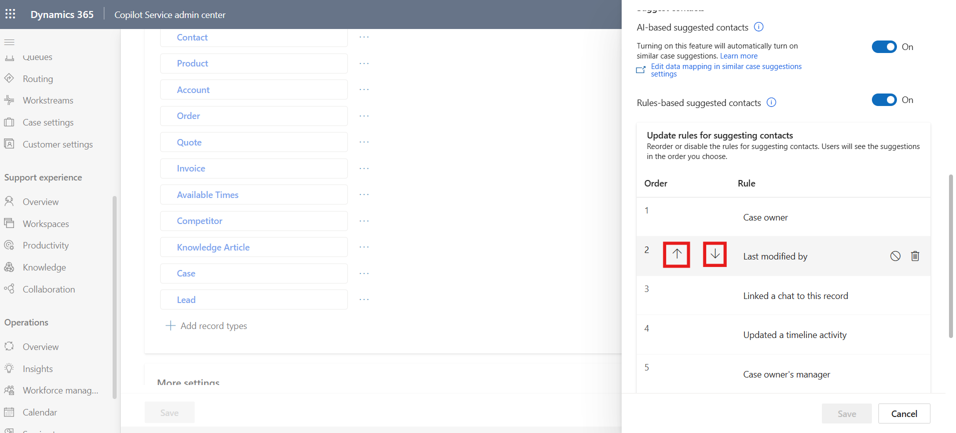
  - To disable a rule, hover over a rule, and then select the disable icon. When the rule is disabled, a check mark is displayed when you hover over the disabled rule.
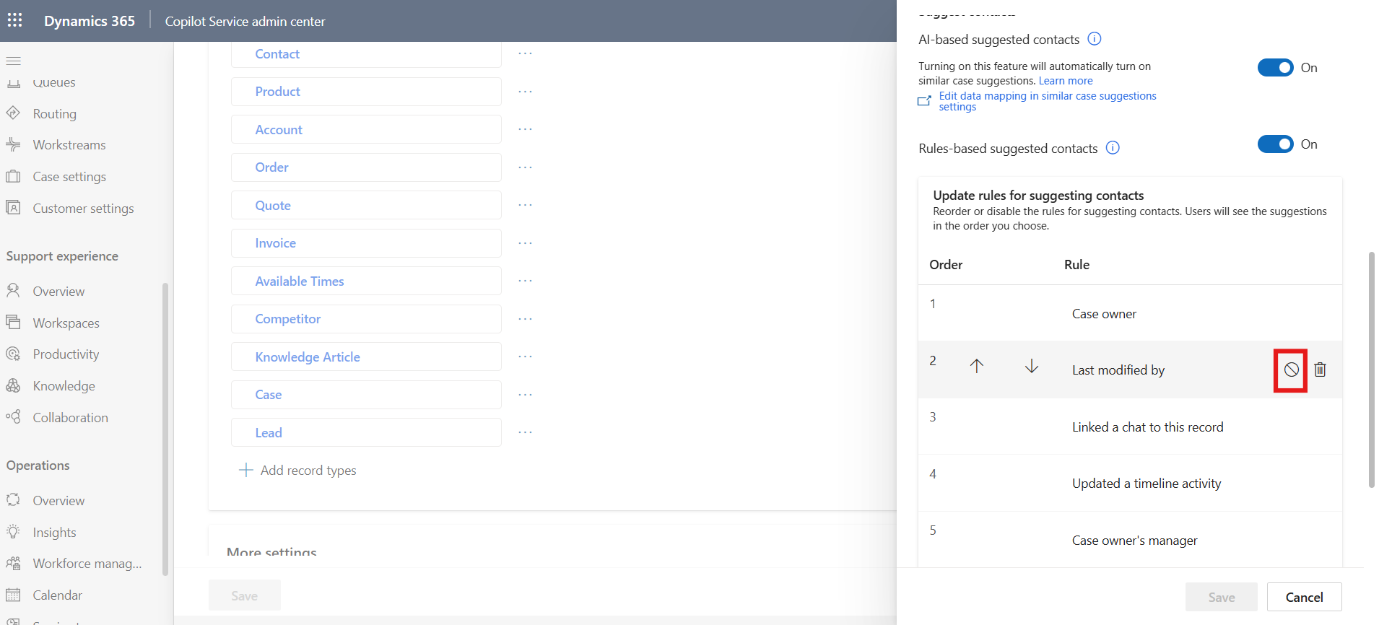
  - To delete a rule, hover over the rule, and then select the delete icon. Deleting a rule removes it entirely so it won’t influence suggested contacts in the future.
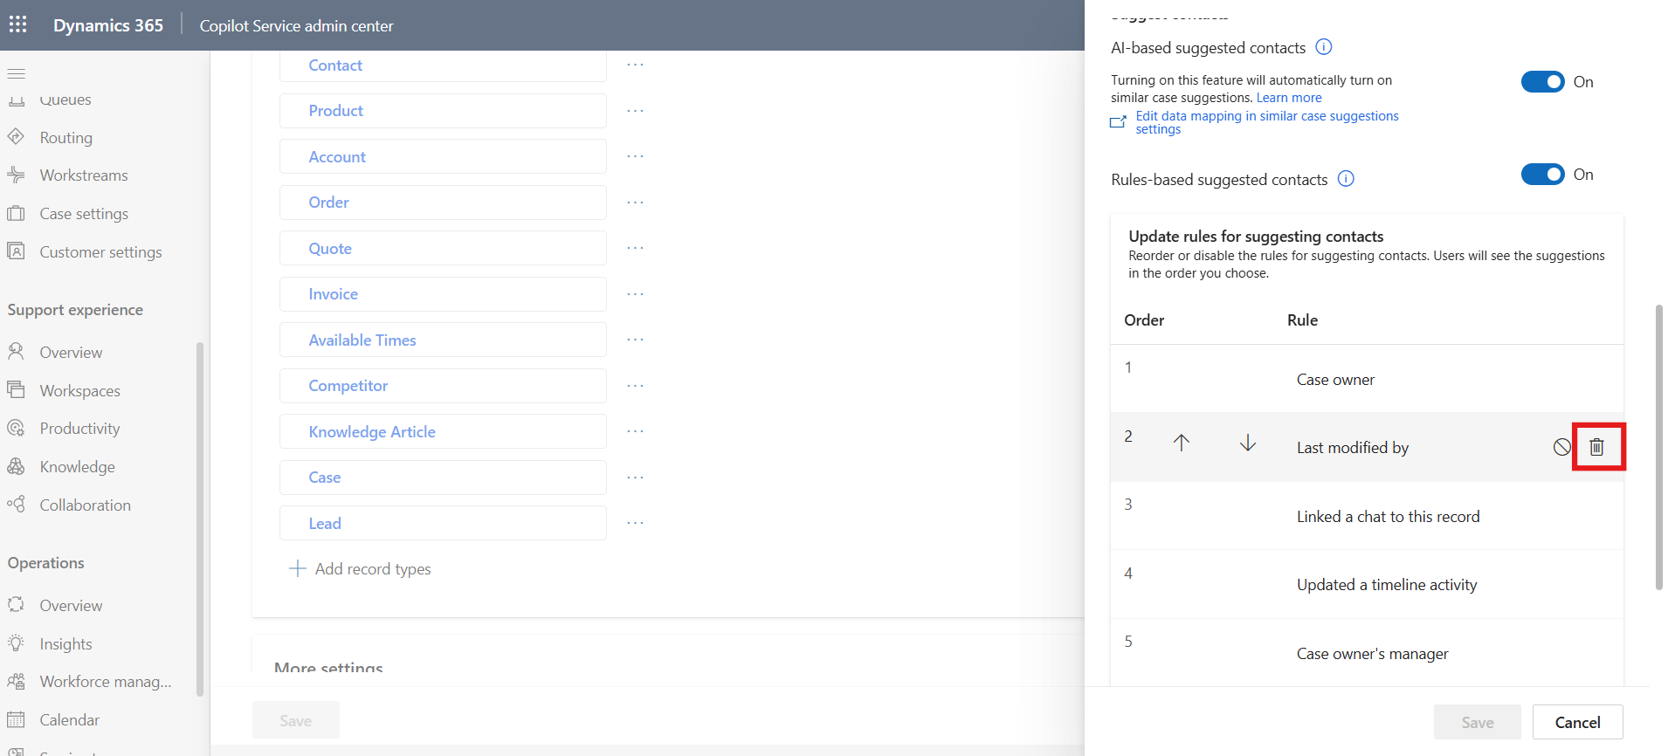
- Select Save.

Task 2 - Add a new rule
- On the settings pane, in the Update rules for suggesting contacts section, select Updates a timeline activity rule.
- Delete the rule.
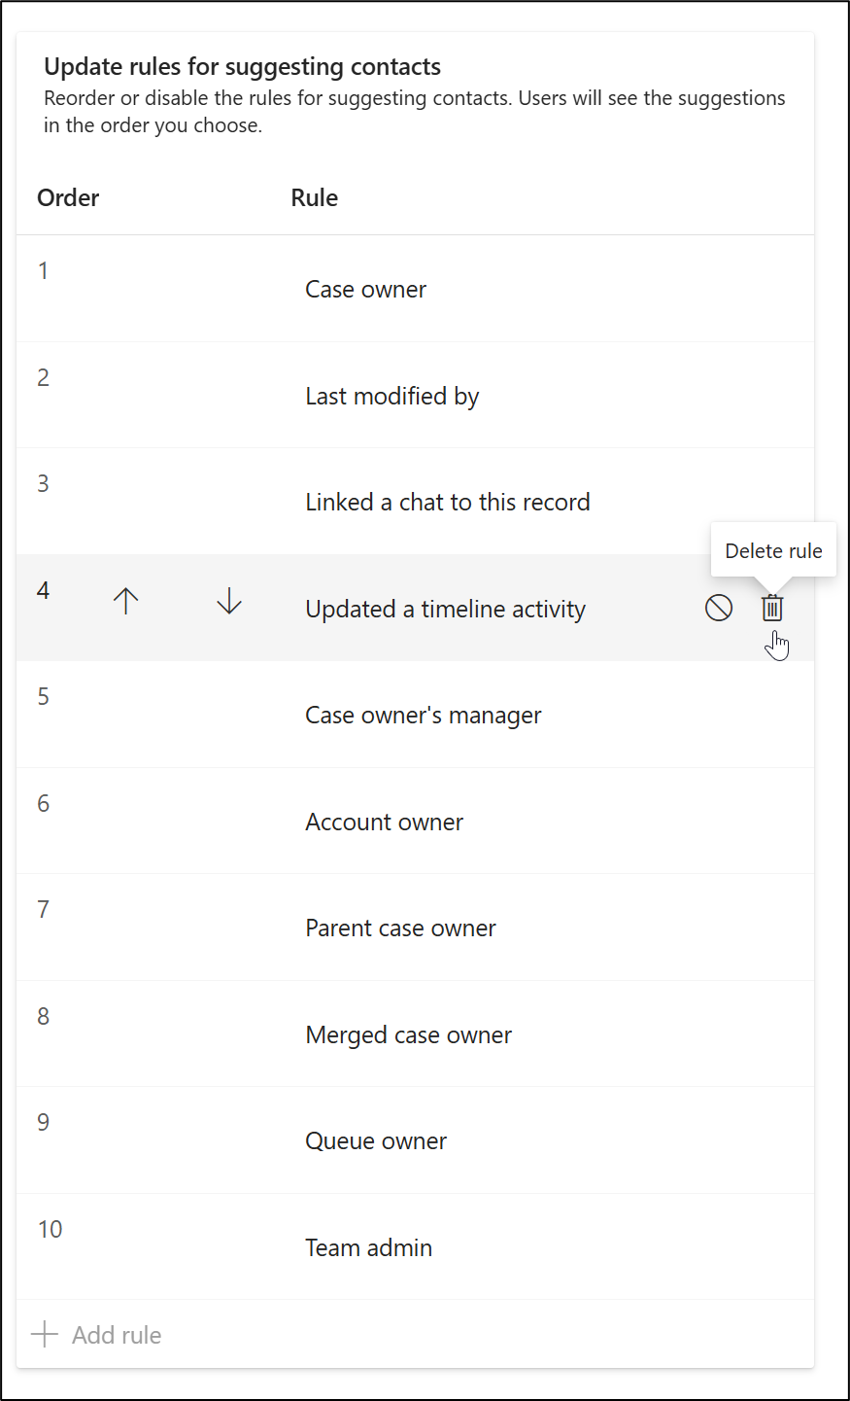
- From the bottom of the section, select + Add rule.
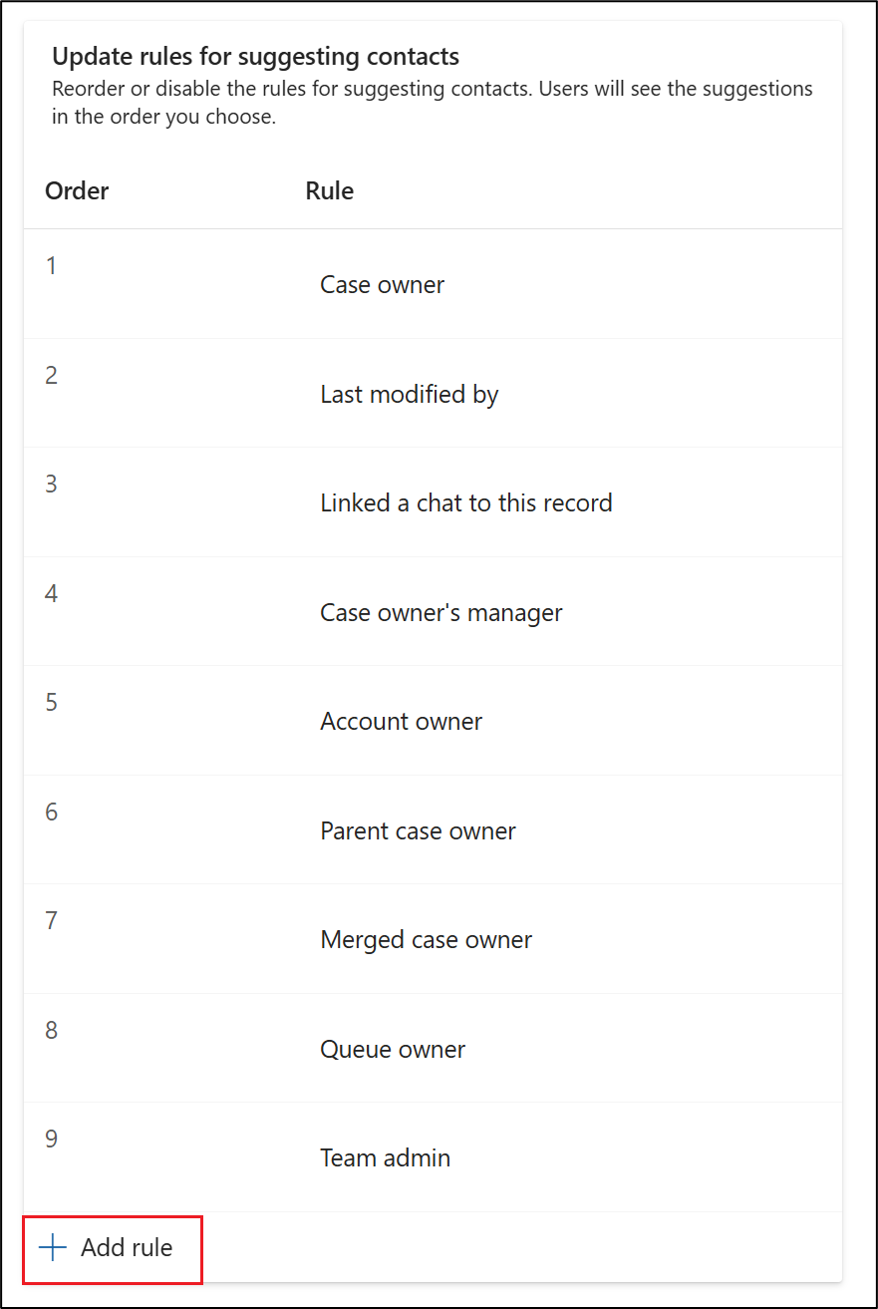
- The Add rule pane is displayed for the selected record type.
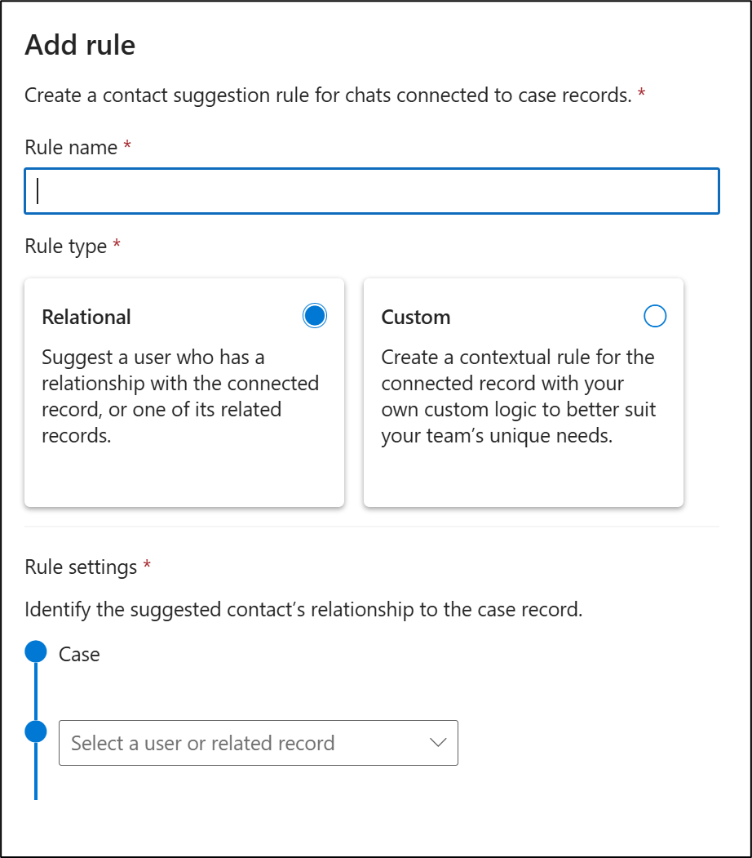
- Enter the following information:
  - Rule name - Created By
  - Rule Type - Relational
  - Select a user or related record - Created By
- Select Save.
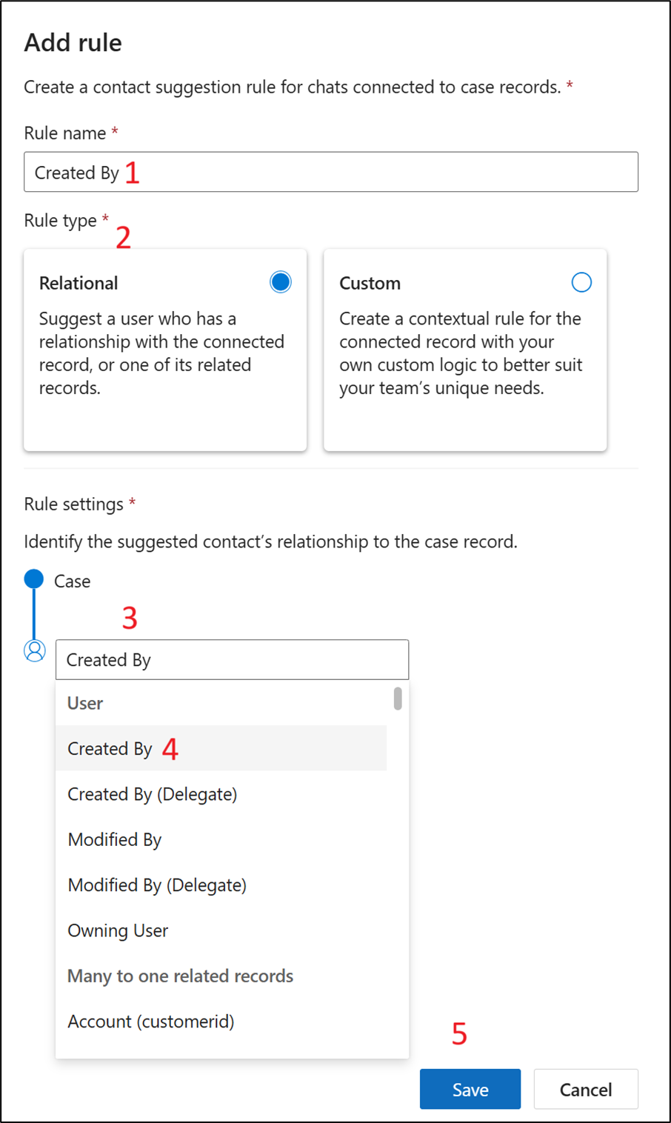
- A new rule is created. Select Save again.
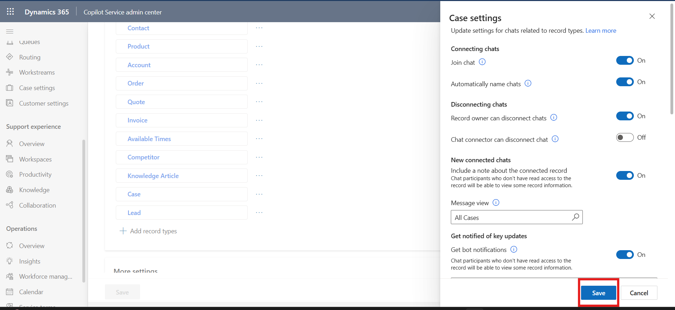
- Select Save on the Microsoft Teams collaboration and chat page.
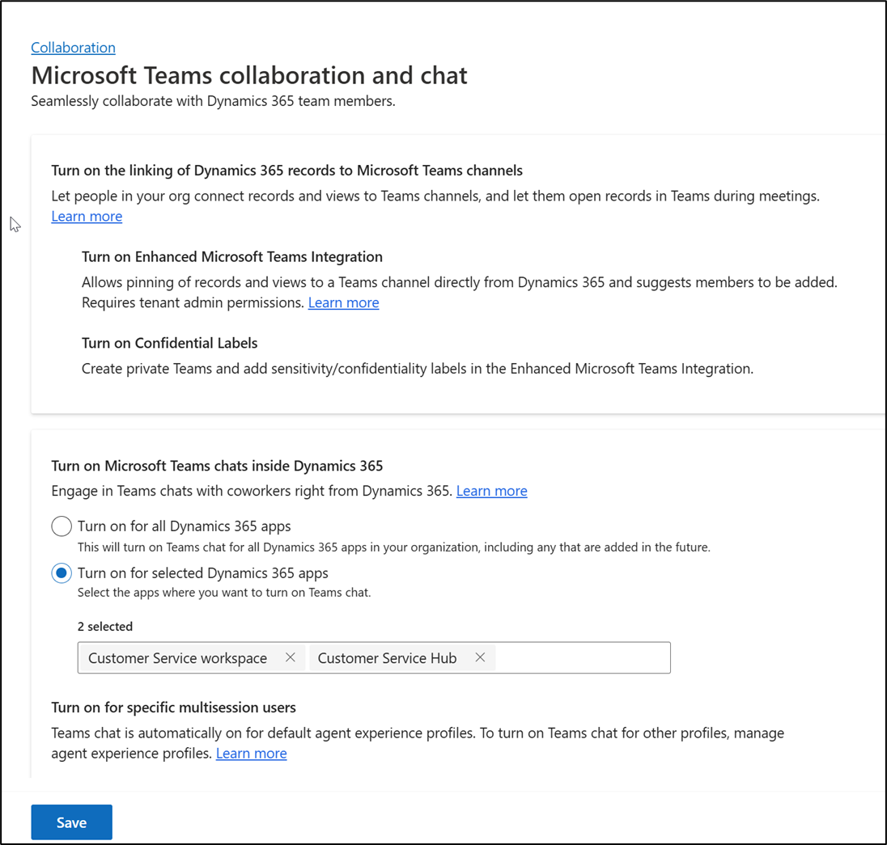

Conclusion
In this lab guide, you configured Microsoft Teams Chat collaboration and suggested contact settings in Dynamics 365 Contact Center. You enabled Microsoft Teams Chat integration, configured chat connections for record types, managed disconnection and join settings, enabled AI-based suggested contacts, and created a rules-based contact suggestion rule. Together, these configurations help establish a more collaborative support environment by connecting Dynamics 365 records with Microsoft Teams-based communication and intelligent contact recommendations.

